

Q.1) Code:

#include <iostream>

using namespace std;

void main()

{

int x;

int y;

float arr[100];

cout << "Please enter total numbers (From 1 to 100): ";

cin >> y;

cout << endl;

for (x = 0; x < y; ++x)

{

cout << "Please enter number " << x + 1 << " : ";

cin >> arr[x];

}

for (x = 1; x < y; ++x)

{

if (arr[0] < arr[x])

arr[0] = arr[x];

}

cout << "Largest element = " << arr[0];

cout << endl;

system("pause");

}

Console:

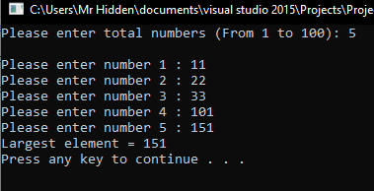

Q.2) Code:

#include<bits.h>

#include<iostream>

using namespace std;

void x(int arr[], int n)

{

int arr1 = 0;

for (int y = 0; y<n; y++)

arr1 += arr[y];

arr1 = arr1 / (n - 1);

for (int a = 0; a < n; a++)

cout << (arr1 - arr[a]) << " ";

cout << endl;

}

void main()

{

int arr2[] = { 10, 14, 12, 13, 11 };

int l = sizeof(arr2) / sizeof(arr2[0]);

x(arr2, l);

system("pause");

}

Console:

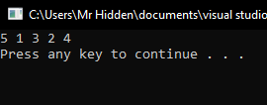

Q.3) Code:

#include<bits.h>

#include<iostream>

using namespace std;

bool x(int arr1[], int y)

{

int z = 0;

for (int a = 0; a<y; a++)

z += arr1[a];

if (z % 2 != 0)

return false;

z = z / 2;

unordered_set<int> s;

for (int i = 0; i<y; i++)

{

int val = z - arr1[i];

if (s.find(val) != s.end())

{

cout<<"Pair elements are:"<< arr1[i]<< val;

return true;

}

s.insert(arr1[i]);

}

return false;

}

void main()

{

int arr2[] = { 2, 11, 5, 1, 4, 7 };

int n = sizeof(arr2) / sizeof(arr2[0]);

if (x(arr2, n) == false)

cout<<"No pair found";

system("pause");

}

Console:

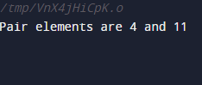

Q.4) Code:

#include<iostream>

using namespace std;

void main()

{

int arr1[10];

int x;

int y;

int a = 0, b = 1;

cout << "Please enter the size of the array : ";

cin >> x;

cout << "Please enter the elements of the array : ";

for (y = 0; y < x; y++)

cin >> arr1[y];

for (y = 0; y < x; y++)

{

a += arr1[y];

b *= arr1[y];

}

cout << "Please enter any alphabet and press enter to see answer" << endl;

cout << "Sum of array elements is : " << a << endl;;

cout << "Product of array elements is : " << b << endl;

cout << endl;

system("pause");

}

Console:

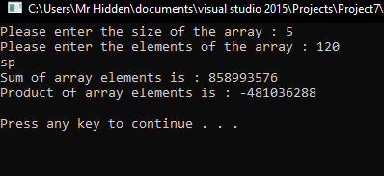

Q.5) Code:

#include <stdio.h>

#include<iostream>

using namespace std;

void main()

{

long int arr1[10], x[10], y[10];

int a, b = 0, c = 0;

int d;

cout << "Please enter the size of array :";

cin >> d;

cout<<"Please enter the elements of the array"<<endl;

for (a = 0; a < d; a++)

{

cout << "Enter element:";

cin>>arr1[a];

fflush(stdin);

}

for (a = 0; a < d; a++)

{

if (arr1[a] % 2 == 0)

{

y[b] = arr1[a];

b++;

}

else

{

x[c] = arr1[a];

c++;

}

}

cout<<"The elements have odd are:"<<endl;

for (a = 0; a < c; a++)

{

cout<<x[a]<<endl;

}

cout<<"The elements have even are:"<<endl;

for (a = 0; a < b; a++)

{

cout << y[a] << endl;;

}

system("pause");

}

Console:

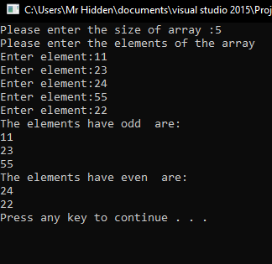

Q.6) Code:

#include <stdio.h>

#include<iostream>

using namespace std;

void main()

{

int arr1[10];

int x, y, a, b, c, d, e;

cout << "Please enter number of elements: ";

cin>>a;

cout << "Please enter the elements:" << endl;

for (x = 0; x < a; x++)

{

cout << "Enter Element:";

cin>>arr1[x];

}

cout << "Please enter array elements:" << endl;

for (x = 0; x < a; x++)

{

cout<<arr1[x];

}

for (x = 0; x < a; x++)

{

for (y = x + 1; y < a; y++)

{

if (arr1[x] > arr1[y])

{

c = arr1[x];

arr1[x] = arr1[y];

arr1[y] = c;

}

}

}

cout << "Sorted list is:" << endl;

for (x = 0; x < a; x++)

{

cout<< arr1[x];

}

cout << endl;

cout << "Please enter the element to be inserted:" << endl;

cin>>d;

for (x = 0; x < a; x++)

{

if (d < arr1[x])

{

e = x;

break;

}

if (d > arr1[a - 1])

{

e = a;

break;

}

}

if (e != a)

{

b = a - e + 1;

for (x = 0; x <= b; x++)

{

arr1[a - x + 2] = arr1[a - x + 1];

}

}

arr1[e] = d;

cout << "Final list is" << endl;

for (x = 0; x < a + 1; x++)

{

cout<<arr1[x];

}

system("pause");

}

Console:

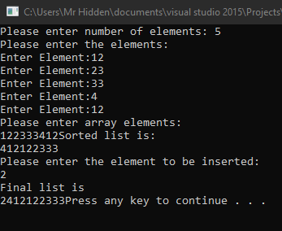

Q.7) Code:

#include <stdio.h>

#include<iostream>

using namespace std;

void main()

{

int a, b, c, d;

int x[30];

cout<<"Please enter the value of N:" << endl;;

cin>>d;

cout<<"Please enter the numbers" << endl;

for (a = 0; a < d; ++a)

cin>>x[a];

for (a = 0; a < d; ++a)

{

for (b = a + 1; b < d; ++b)

{

if (x[a] > x[b])

{

a = x[a];

x[a] = x[b];

x[b] = a;

}

}

}

cout << "The numbers arranged in ascending order are given as below as following:" << endl;

for (a = 0; a < d; ++a)

cout << x[a] << endl;

system("pause");

}

Console:

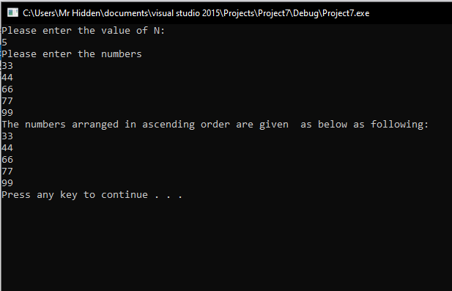

Q.8) Code:

#include<iostream>

using namespace std;

void main()

{

int x, a, b, c;

int arr1[50];

cout << "Please enter total Number of Elements : ";

cin >> x;

cout << endl;

cout << "Please Enter " << x << " Elements :"<<endl;

for (a = 0; a<x; a++)

{

cout << "Please enter number";

cout << " ";

cin >> arr1[a];

}

cout << endl;

cout << "Sorting Array using Bubble Sort as:";

for (a = 0; a<(x - 1); a++)

{

for (b = 0; b<(x - a - 1); b++)

{

if (arr1[b]>arr1[b + 1])

{

c = arr1[b];

arr1[b] = arr1[b + 1];

arr1[b + 1] = c;

}

}

}

cout << endl;

cout << "Sorted Element in Ascending Order are :" << endl;

for (a = 0; a<x; a++)

{

cout << " ";

cout << arr1[a] << " ";

cout << endl;

}

system("pause");

}

Console:

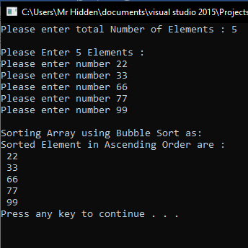

Q.9) Code:

#include <stdio.h>

#include<iostream>

using namespace std;

int a(int c, int d);

void x(int c)

{

for (int line = 0; line < c; line++)

{

for (int b = 0; b <= line; b++)

printf("%d ",

a(line, b));

cout << " " << endl;

}

system("pause");

}

int a(int c, int d)

{

int e = 1;

if (d > c - d)

d = c - d;

for (int i = 0; i < d; ++i)

{

e *= (c - i);

e /= (i + 1);

}

return e;

system("pause");

}

void main()

{

int h;

cout << "Pascal's Triangle" << endl;

cout << "Please enter number of rows:";

cin >> h;

x(h);

system("pause");

}

Console:

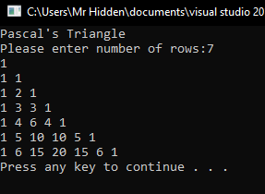

Q.10) Code:

#include<iostream>

using namespace std;

const int g = 10;

const int y = 5;

int matrix[g][y];

void x(int m[][y], int z);

int main()

{

const int a = 10;

string Name[a] = { "Johnson","Aniston","Cooper","Gupta","Blair","Clark","Kennedy","Bronson","Sunny","Smith" };

for (int i = 0; i < a; i++)

const int w = 10;

const int f = 5;

int h[g][y] = { { 85, 83, 77, 91, 76 },

{ 80, 90, 95, 93, 48 },

{ 78, 81, 11, 90, 73 },

{ 23, 45, 96, 38, 59 },

{ 60, 85, 45, 39, 67 },

{ 77, 31, 52, 74, 83 },

{ 93, 94, 89, 77, 97 },

{ 79, 85, 28, 93, 82 },

{ 85, 72, 49, 75, 63 } };

x(h, g);

cout << endl;

return 0;

}

void x(int m[][y], int z)

{

int s, j;

int l;

for (s = 0; s < z; s++)

{

l = 0;

for (j = 0; j < y; j++)

l = l + m[s][j];

cout << "average =" << (s + 1) << l << endl;

}

system("pause");

}

Console:

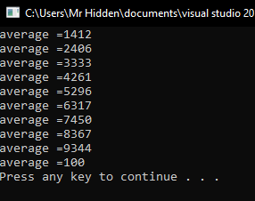

-------------------------------------------------------------Thankyou----------------------------------------------------